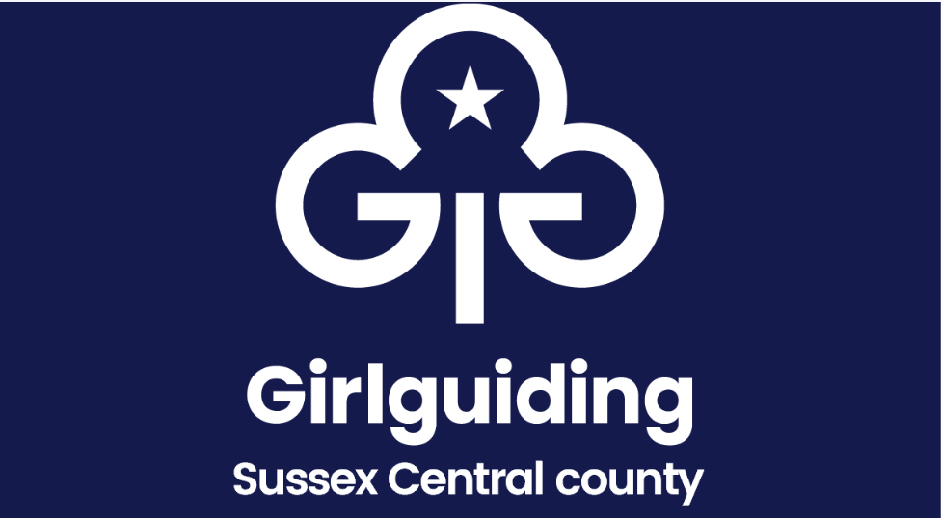

Annual Accounts: Division Feedback Form for Districts for 2024

The Feedback Form is designed to assist in checking the compliance of accounts with the Girlguiding Finance Policy (2024).
Division Commissioner, or designated person, can use this form to check that all District accounts have been seen each with a complete unit certification.

Unit/ District | Signed  Finance Certificates Submitted | Verified Accounts  Submitted | Comments/concerns to raise to Division / District in 2025
(insert name)
District
Commissioner

Treasurer

xxx
District
Commissioner

Treasurer

xxx
District
Commissioner

Treasurer

xxx
District
Commissioner

Treasurer

