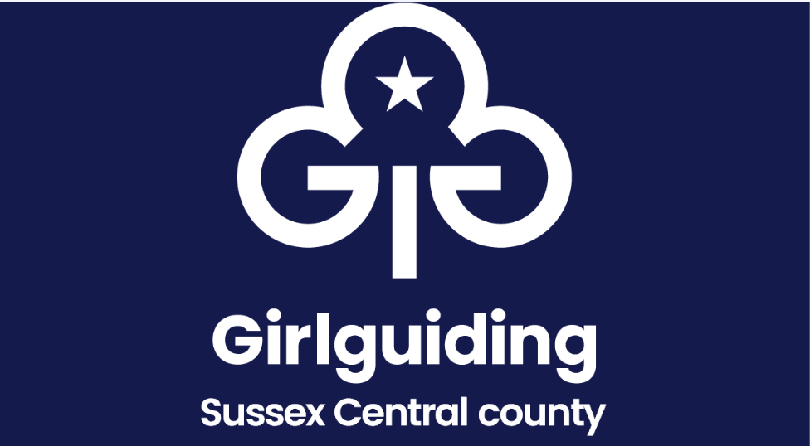

Annual Accounts: District Feedback Form for District/ Units for 2024

The Feedback Form is designed to assist in checking the compliance of accounts with the Girlguiding Finance Policy (2024).
District Commissioner, or designated person, can use this form to check that all unit accounts have been seen each with a completed unit certification.

Unit /District | Signed  Finance Certificate Submitted | Verified Accounts  Submitted | Comments/concerns to raise to Division / District in 2025
xxx
District
Commissioner

Treasurer

UNIT name
Leader

Treasurer

UNIT name
Leader

Treasurer

UNIT name
Leader

Treasurer

UNIT name
Leader

Treasurer

UNIT name
Leader

Treasurer

