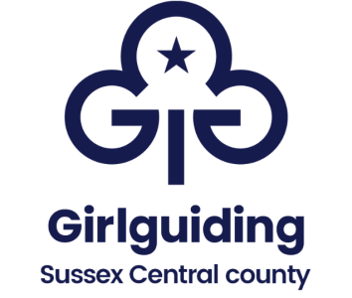

Annual Accounts for year ending: 2024 UNITS Key Dates and process

It is a requirement that all unit accounts are verified annually by an independent person and presented to the District Commissioner. In the absence of a District Commissioner, accounts should be presented to the Division Commissioner/designated person.
Full details are available here https://www.girlguiding.org.uk/information-for-volunteers/running-your-unit/finance-insurance-and-property/unit-finances/end-of-year-reviews/
An independent person is someone who is NOT a member of the unit leadership team, NOT related to anyone in the unit and is NOT a signatory on the account. These dates assume a December year end.

From 10th January
The unit leader or unit treasurer prepares the accounts ready to be handed to the independent verifier along with:
- Bank statements showing all transactions to 31st December 2024
- Paying in books
- Cheque books
- Invoices
- Receipts
- The unit leader/treasurer checks that the accounts agree with the amount showing in the bank. If there is a difference, a note is added to the accounts explaining why this is (a bank reconciliation).
- If this cannot be made to agree, assistance should be requested as soon as possible (could be from another leader, the district treasurer etc.)
- The unit leader or treasurer then completes the Sussex Central Finance Certification for Units

By 31st January i.e. 2-3 weeks from receipt of last bank statement
- The unit leader/treasurer passes the unit accounts to an independent person for verification together with all relevant items on the Checklist( as above). This COULD BE the District Treasurer by agreement.

By 22nd February This gives verifier 3 weeks with 22nd February, an easy date to remember
- The unit leader/treasurer collects the verified accounts and completed Unit Finance Certifications and passes these to the District Commissioner, or in the case of there not being anyone in post, to the Division Commissioner.

We very much hope that this suggested timeline will assist you in submitting the unit accounts in good time so as to comply with Girlguiding Policy requirements and we thank you for your efforts on County’s behalf.
Nov.2024

